S1739768

DAH ‘Checkpoint 3: Sampling Analogue Signals’ Submission Document

***1. What time did you calculate elapsed between samples?***

A typical time elapsed between samples was 0.00283774 s (sampling interval).

***2. What did you calculate was the highest signal frequency you can measure correctly (and why)? Provide a plot showing your sampling of an input waveform at this frequency.***

Highest correctly measurable frequency given by Nyquist Frequency.

$$Nyquist Frequency=\frac{1}{2}×sampling rate$$

$$=\frac{1}{2}×\frac{1}{sampling interval}$$

$$=\frac{1}{2}×\frac{1}{0.00283774 s}$$

$$=176.2 Hz$$

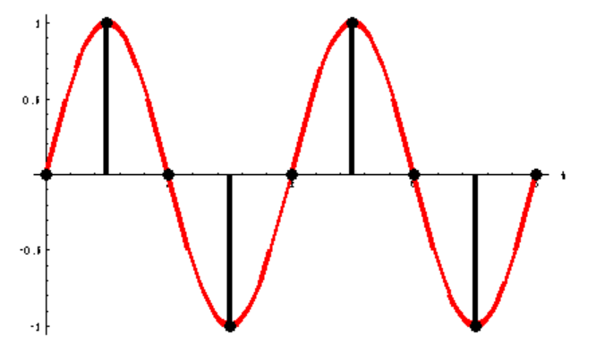To reasonably sample a sinusoidal signal, the more samples taken per period of the signal, the better. Theoretically, the minimum number of samples required to determine the frequency and magnitude to be taken per period is two, see Fig.1.

Fig.1: from <http://microscopy.berkeley.edu/courses/dib/sections/02Images/sampling.html> two samples per period accurately recreates a sinusoidal signal fitting a sine curve

Therefore, taking exactly two samples per period means the sampling rate must be twice the signal frequency. In other words, the Nyquist frequency is half the sampling rate. A plot taken in the lab measuring a signal of frequency equal to the Nyquist frequency is shown in Fig.2. Due to the Nyquist frequency being only estimated and the signal generator input being one decimal place precision, there are beats with an inner frequency of ~175 Hz, the correctly measured frequency. However, because of the beats, the magnitude was not accurately recreated. The lab plot also just joined the points with straight lines instead of fitting a sine curve, so a higher sampling rate would be needed to better sample the signal in practice.

Fig.2: Sampling Nyquist frequency = 176.2 Hz shows beats with an inner frequency of ~175 Hz so correctly recreates the frequency 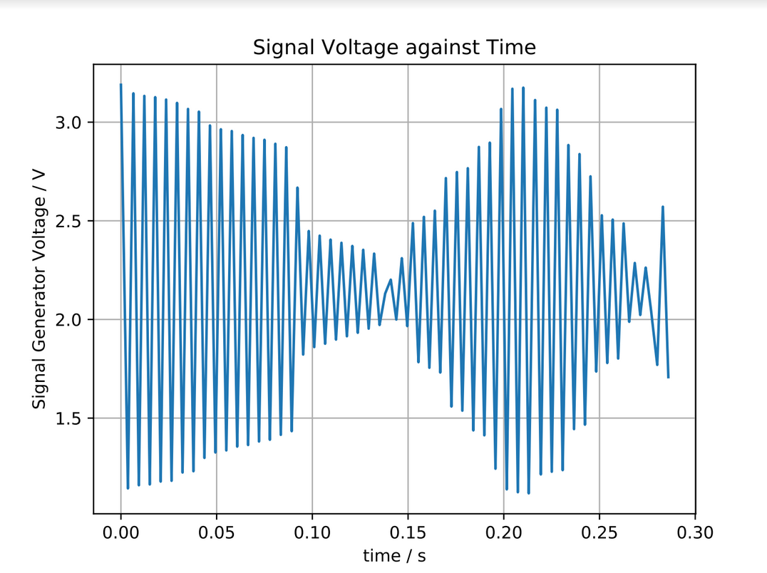

***3. Explain what happens when a waveform is undersampled, and provide a plot that shows what you describe.***

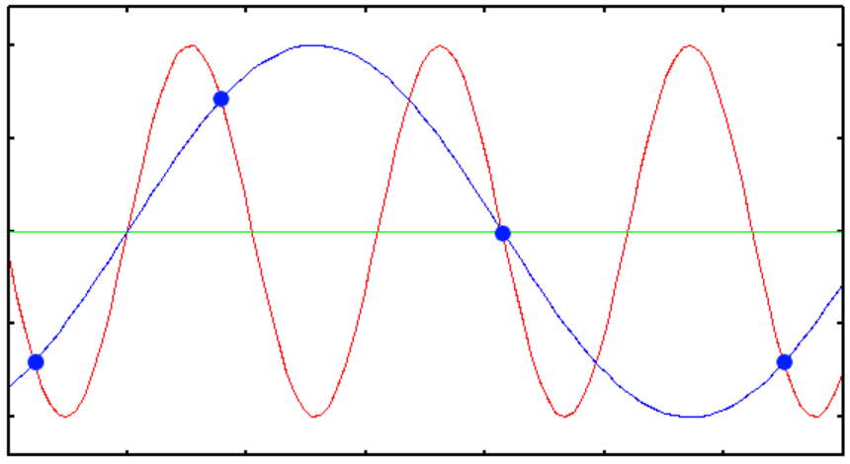The sampling is periodic so still results in a periodic signal measurement, but the accuracy of the frequency measured is limited by the sampling rate which is not high enough to properly recreate the signal being measured (does not meet Nyquist criteria). This arises from the sequential samples being taken out with the same period, see fig.3.

Fig.3: waveform in red inaccurately recreated by samples in blue as sequential samples being taken out with the same period from <https://svi.nl/UnderSampling>

A plot taken in the lab sampling a 1 kHz signal is shown in fig.4. The plot shows a frequency of ~50 Hz so is inaccurately measured due to undersampling.

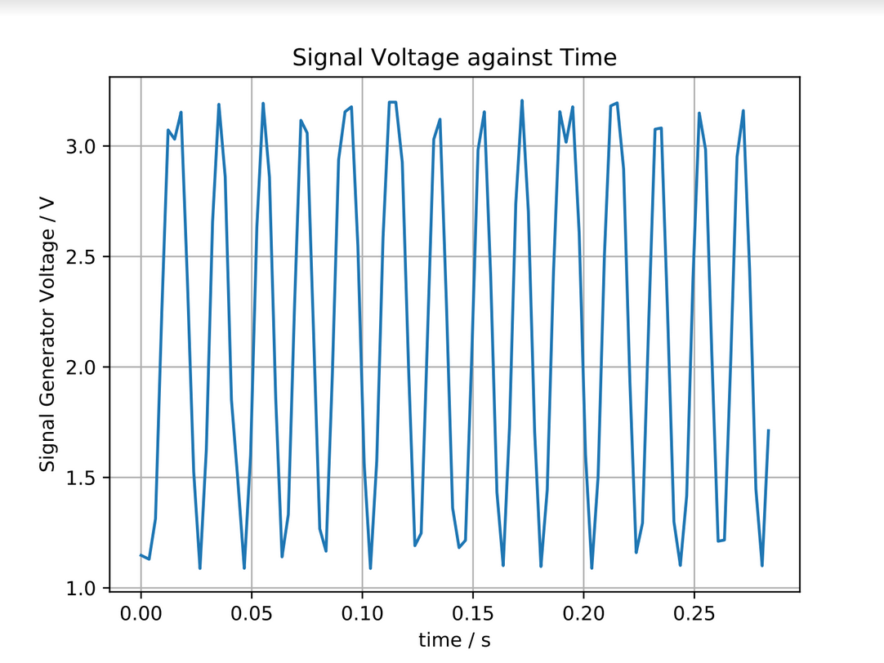Fig. 4 Undersampled signal measurement from the lab: true signal was 1 kHz but plotted signal is ~50 Hz so is a false representation of the signal